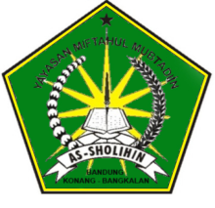

**STRUTUR PERLOMBAAN LARI KARUNG**

**YASMIN**

**MASA JUANG 2017-2018**

Homsiyeh(7) (4)

Bunaimah(6)

Roni (5)

Holis (4)

Aisyah (9)

Solihin (8)

Ridoi (8)

Ningsih (7)

Nurfadila (9)

Ulum (4)

Asis (5)

Rohmah (6)

Jamila (4)

Lukman (6)

Husnun n (7)

Rodiyah (9)

Buhori (8)

Sanah (5)